George Smith

1/21/2021

Lab 1

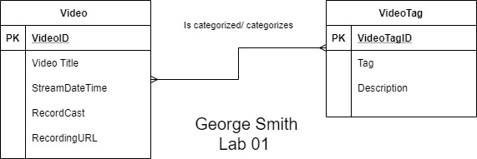

1. Identify four challenges to fitting this data into the relational database model
   1. Not every record has a User Tag associated with it.
   2. Stream date contains multiple date formats.
   3. Some stream date rows have more than one record.
   4. Video duration format is not consistent.